Ch Xtreme Fidelis Caribou Barbie
“Palin”
DOB 11/ 10/08
OFA Hips / elbows, Cardiac
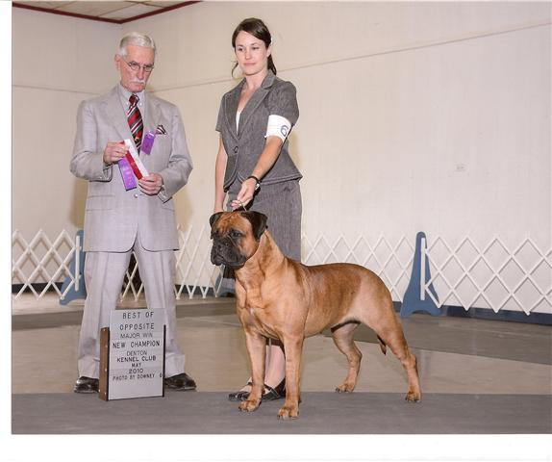

BISS  Ch Newcastles Semper Fidelis Samson  OFA  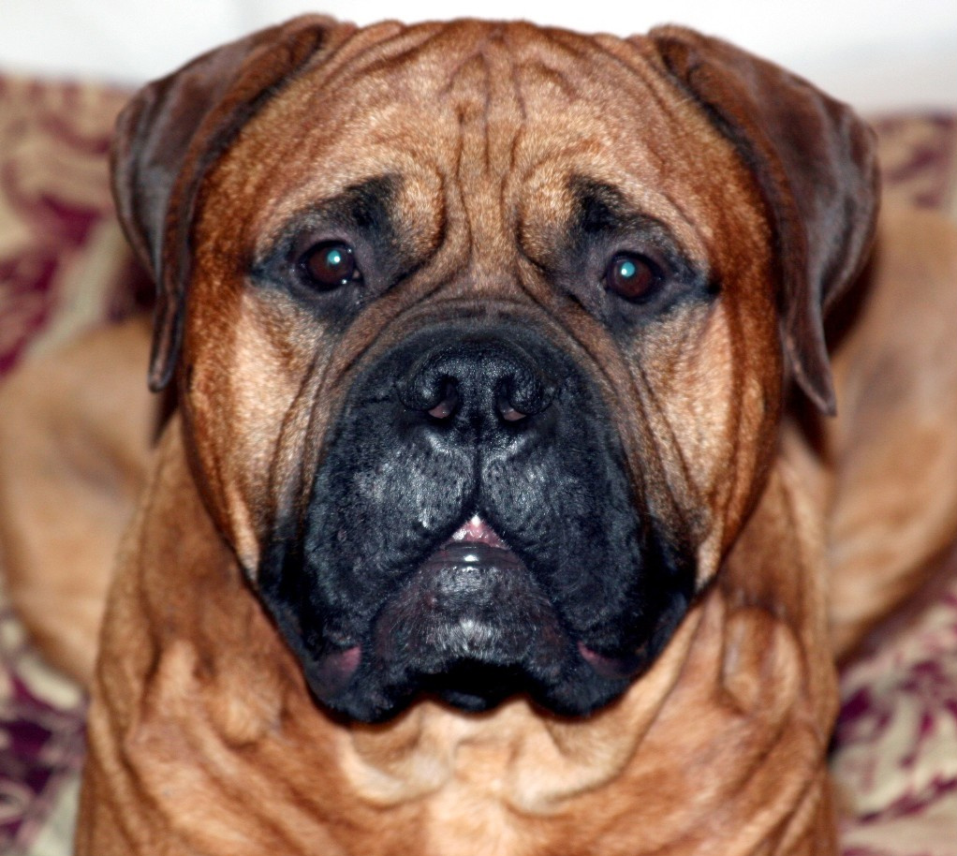 | BIS BISS Ch Tondra's Heres The Beef | BISS Ch Mikell Ranah's Of Leatherneck | CH Ladybug's Handsome Sampson
 | BIS BISS Ch Tondra's Heres The Beef | BISS Ch Mikell Ranah's Of Leatherneck | Ch Leathernecks Golly Miss Molly
 | BIS BISS Ch Tondra's Heres The Beef | Ch Tondra's Northern Exposure | Ch Blossom's Bullwinkle
 | BIS BISS Ch Tondra's Heres The Beef | Ch Tondra's Northern Exposure | Ch Shady Oaks Cassie CDX TD
 | Ch Blazin's Princess Borghesse | Ch Blazin's The Buck Starts Here | Ch Blazin's Valhalla
 | Ch Blazin's Princess Borghesse | Ch Blazin's The Buck Starts Here | Ch Blazin's Destined To Be Mine
 | Ch Blazin's Princess Borghesse | Ch Blazin's Dream Lover | Ch Ladybug Essex At Shastid
 | Ch Blazin's Princess Borghesse | Ch Blazin's Dream Lover | Ch Blazin's Princess Taj
BISS CH Xtreme's Miss Conduct  OFA Chic#  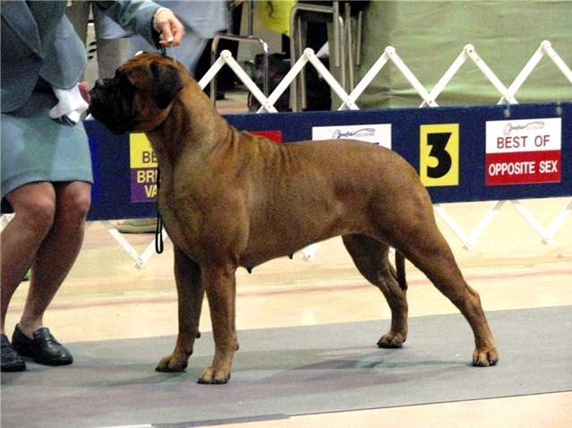 | BISS Ch Ashlock's Zam B Z Zinger | Ch. AM/CAN CH Bastion's Ashlck Runfortheroses | CH Bluegrass Bumptious Boo
 | BISS Ch Ashlock's Zam B Z Zinger | Ch. AM/CAN CH Bastion's Ashlck Runfortheroses | AM/CAN CH Bastion's Hellcat From Hytop
 | BISS Ch Ashlock's Zam B Z Zinger | Ch Dustyrose's Sundre At Ashlock | BIS & BISS AM/CAN CH Bastion's Celebration Time ROM
 | BISS Ch Ashlock's Zam B Z Zinger | Ch Dustyrose's Sundre At Ashlock | Ch Mikell Ranak Of Leatherneck
 | Ch Xtreme's Dancin Diva Of Eloc  OFA | BISS Ch Titan's Minister Of Defense ROM | Bedrock's Shaquille Of Titan
 | Ch Xtreme's Dancin Diva Of Eloc  OFA | BISS Ch Titan's Minister Of Defense ROM | Ch Blossom Sweetnutmeg Of Titan
 | Ch Xtreme's Dancin Diva Of Eloc  OFA | Ch Eloc's Uh Oh Gardienne | CH Eloc Copper Magician
 | Ch Xtreme's Dancin Diva Of Eloc  OFA | Ch Eloc's Uh Oh Gardienne | Ch Nitestalkers Brighton Sassy Crom-20

