Ch Xtreme’s Miss Conduct | Ch Ashlocks Zam B Z Zinger  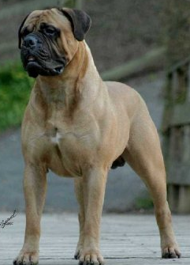 | CH Bastion's Ashlck Runfortheroses  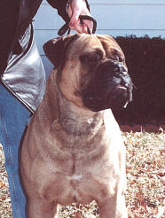 | CH Bluegrass Bumptious Boo  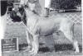
Ch Xtreme’s Miss Conduct |  |  | CH Bastion's Hellcat From Hytop  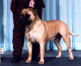
Ch Xtreme’s Miss Conduct |  | Ch Dustyrose's Sundre At Ashlock  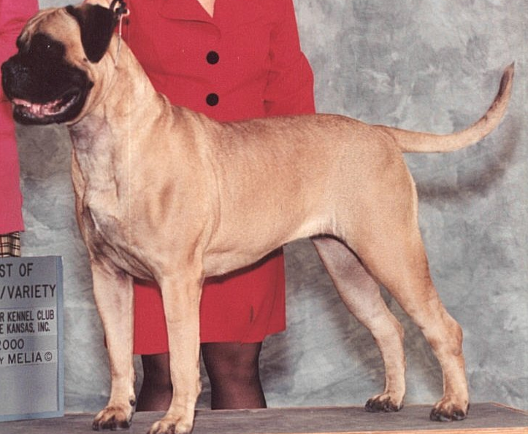 | BIS & BISS AM/CAN CH Bastion's Celebration Time ROM  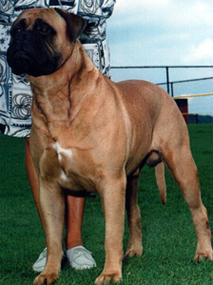
Ch Xtreme’s Miss Conduct |  |  | Mikell Ranak Of Leatherneck
Ch Xtreme’s Miss Conduct | Ch Xtreme’s Dancin Diva of ELOC  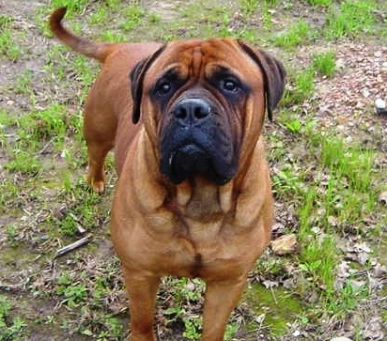 | Ch Titan’s Minister Of Defense  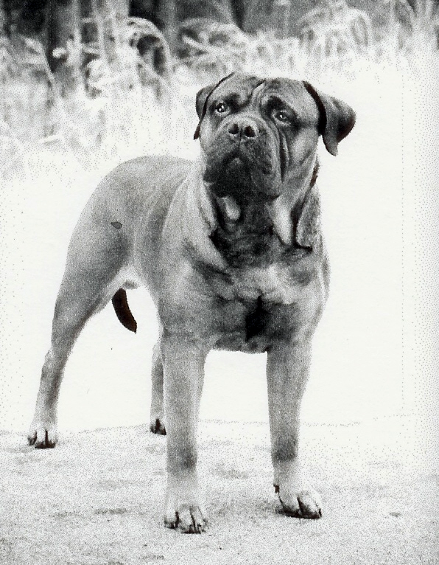 | Bedrock's Shaquille Of Titan
Ch Xtreme’s Miss Conduct |  |  | Am Ch Blossom Sweetnutmeg Of Titan Ch
Ch Xtreme’s Miss Conduct |  | Ch Eloc's Uh Oh Gardienne  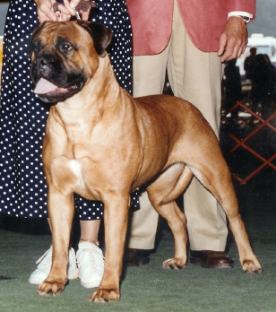 | CH Eloc's Copper Magician  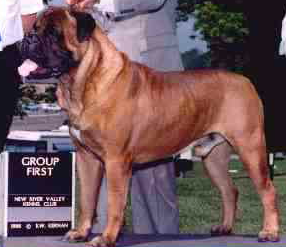
Ch Xtreme’s Miss Conduct |  |  | CH Nitestalkers Brighton Sassy  