Sam Pic Ped
Ch Newcastles Semper Fidelis Samson  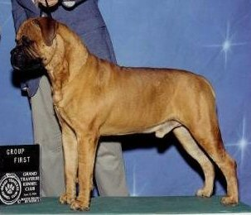 | Ch Tondra's Heres The Beef  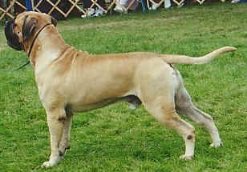 | Ch Mikell Ranah's Of Leatherneck  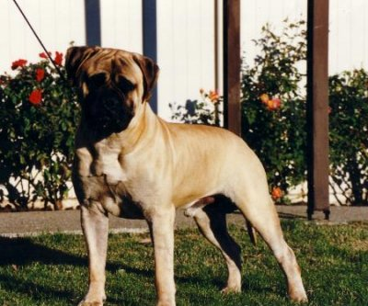 | CH Ladybug's Handsome Sampson
 |  |  | Am Ch Leathernecks Golly Miss Molly
 |  | Ch Tondra's Northern Exposure  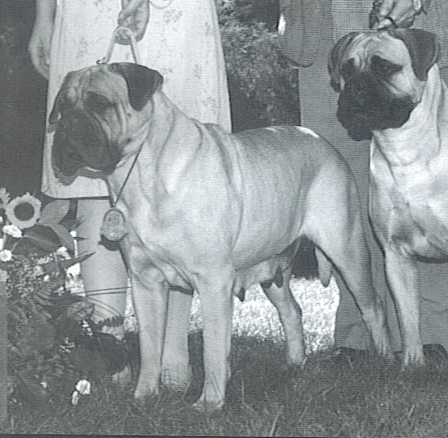 | Am Ch Blossom's Bullwinkle
 |  |  | Ch Shady Oaks Cassie CDX TD
 | Ch Blazin's Princess Borghesse  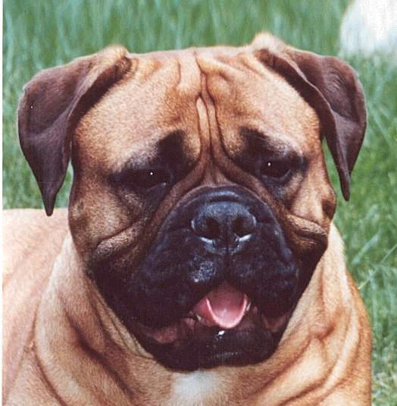 | Ch Blazin's The Buck StartsHere 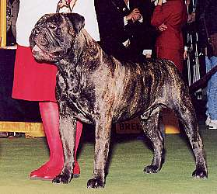 | Am Ch Blazin's Valhalla
 |  |  | Am Ch Blazin's Destined To Be Mine
 |  | Ch Blazin's Dream Lover  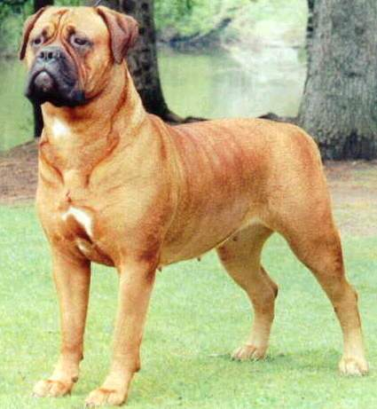 | CH Am Ch Ladybug Essex At Shastid
 |  |  | Am Ch Blazin's Princess Taj

