Future Star

Xtreme's Annies Endeavor
"Zena"

Ch Monarch Kemosabe X Shooky's southern Belle

This sweet girl just won her first point at 6 months old. She has lots of bone and will have a nice head when she matures. We are anxious about this girls potential!
Owned by Ann Mollico and Xtreme

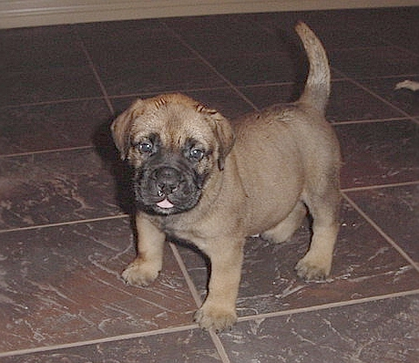
8 wks old

