Ch Essex Semper  Fidelis Delilah  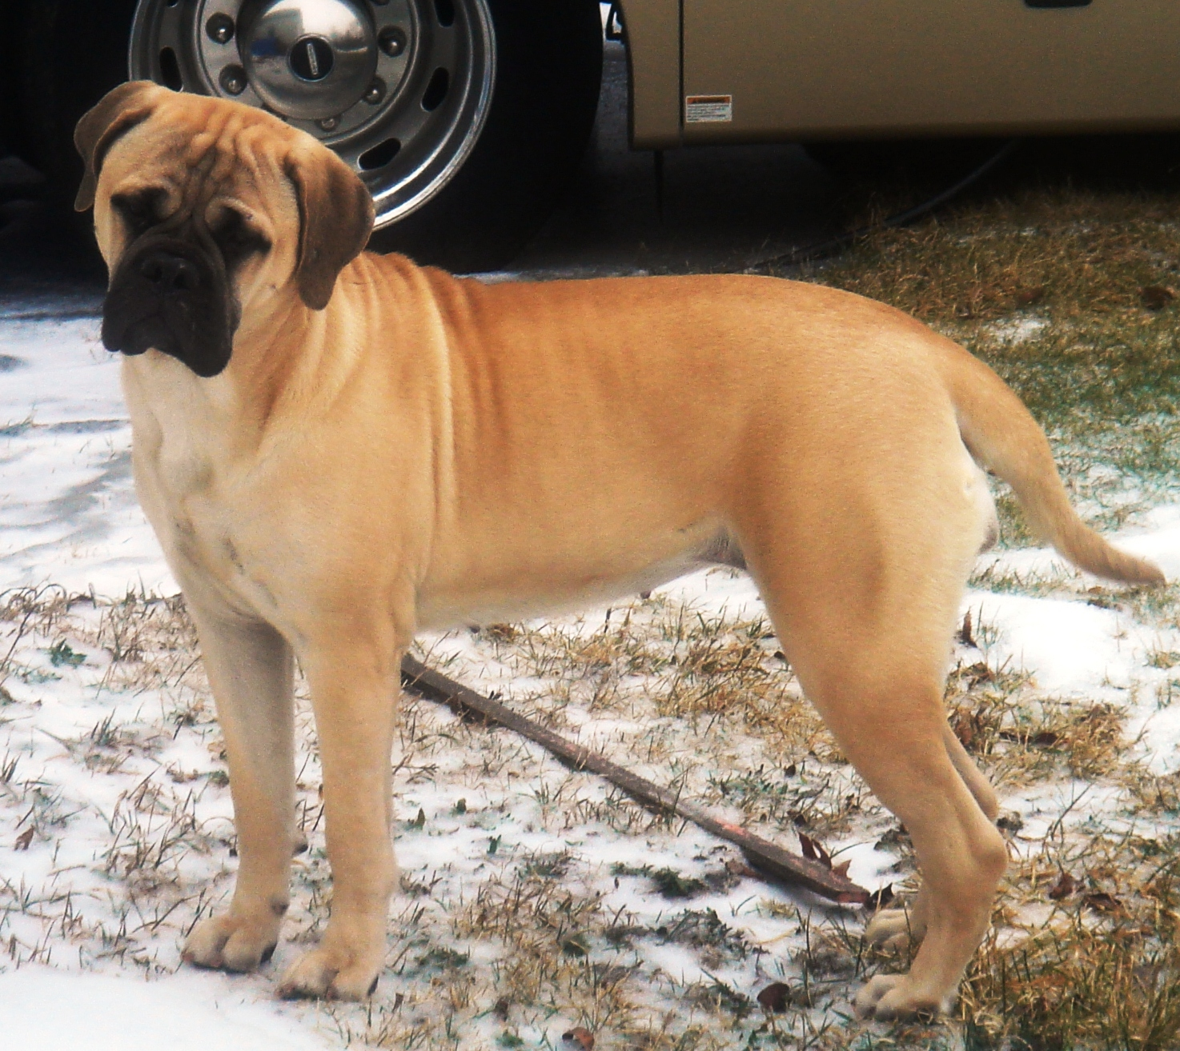 | Ch Nambe Hy-bull  Quote The Raven  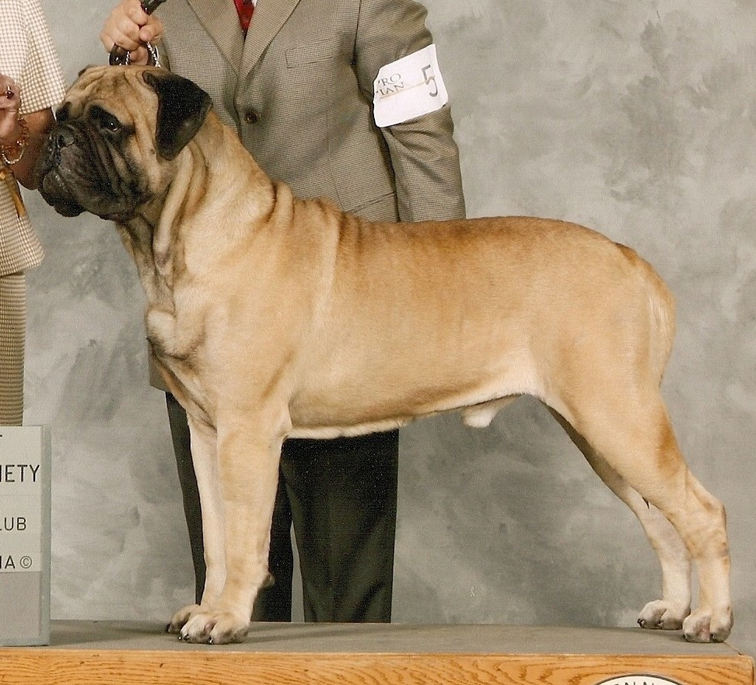 | CH Essex One For The Money  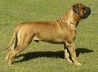 | CH Mikell Ranah's Of Leathernek  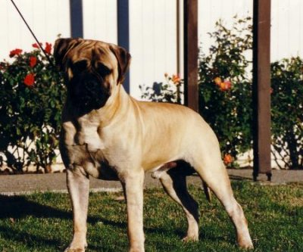
 |  |  | CH Essex Go Kat Go
 |  | Ch Hy-Bull’s Nessa  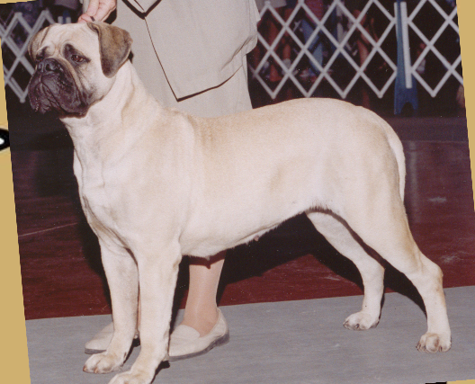 | Ch Ladybug Shas Braminson
 |  |  | Ch Shastid Ladybug Bit O Hybull
 | Ch Essex Payday  From Hy-Bull | Ch Essex Storybook Allstar  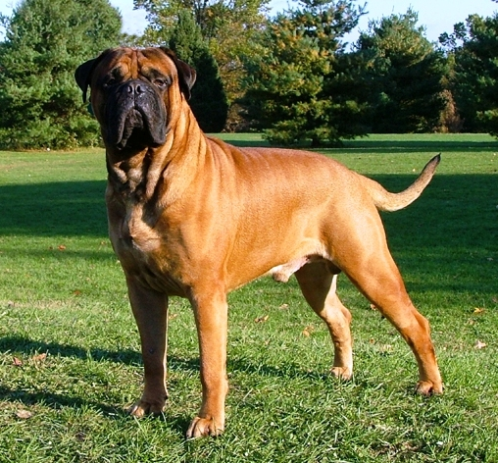 | Ch Ladybug Shastid Brahminson
 | Ch Essex Payday  From Hy-Bull |  | Ch Essex Go Cat Go
 | Ch Essex Payday  From Hy-Bull | Ch Shastid Ladybug Bit O Hybull | Ch Mikell Ranah's Leatherneck
 | Ch Essex Payday  From Hy-Bull | Ch Shastid Ladybug Bit O Hybull | Ch Licassa Delightl Lady Oldwell

